Design VPC Service Catalog - VPC as a Service
[ Description ] [ Scope ] [ Architecture ] [ Design ] [ Requirements ] [ Description of Components ] [ AWS Service Catalog ] [ Tenant Account Resources: ] [ AWS CloudFormation ] [ AWS Lambda Custom Resource ] [ AWS SNS Custom Resource ] [ VPC Flow Logs ] [ Central Account Resources: ] [ AWS SNS ] [ AWS Secrets Manager ] [ AWS KMS ] [ AWS Lambda ] [ Infoblox Integration and API ] [ Deployment Dependencies ]

Description
VPC as a Service intends to give Customers the ability to provision a Dedicated VPC, one per region, from the Service Catalog Service within a Customer account. The product would create a Dedicated VPC in any supported regions.

Scope
The scope of this product is to create the following a TGW dedicated, Intranet routable VPC with /26 CIDR in Customer Managed AWS accounts.

Architecture
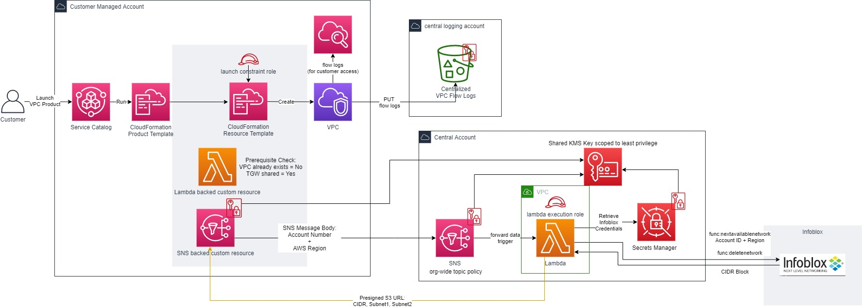

Design

Requirements
- Product should stop provisioning if there is already a VPC in the account. This constraint applies to accounts with Shared VPCs as well.
- Service will provide new VPC with CIDR block size of /26
- Service shall limit creation to a single VPC per region per account
- Service will check if a shared TGW exists before allowing VPC creation
- Service shall exclude accounts connected to shared VPC
- Service should not provision different connectivity types in same account
- Service shall provide connectivity to the network
- Service shall work in GovCloud and Commercial

- Tenant Account
  - Launch VPC SC product
  - Lambda custom resource in the CFT performs a series of checks
    - Checks if an existing VPC is already created
    - Checks if the TGW is shared to the account
  - If VPC does not exist and TGW exists
    - SNS based custom resource performs the following:
      - sends details (account number, etc)
      - Lambda function triggered in central account
- Central Account
  - Triggered lambda function performs API call to Infoblox
  - Checks for available CIDR in network container
- Infoblox
  - If available CIDR exists
    - Sends next available IP CIDR range
    - Update record with Account ID and region
- Central Account
  - Lambda function receives IP CIDR range
  - Creates 2 subnet ranges from CIDR
  - Sends IP CIDR and subnet range to tenant account
- Tenant Account
  - VPC is created
  - VPC is attached to TGW
  - 2 subnets are created
  - Creates up two vpc flow logs
    - VPC flow logs to Centralized VPC Flow Log repo (S3 Bucket in central logging)
    - local Cloudwatch log group

Description of Components

AWS Service Catalog
Service used by customers to deploy this product whereby customers would be able to access the service catalog console and select this product and click launch. This would then deploy a cloudformation template inside of the customer's account resulting in a VPC for the specified region.

Tenant Account Resources:

AWS CloudFormation
Infrastructure as Code native AWS Service that contains a collection of resources including:
  - VPC
  - 2 subnets
  - Availability Zone
  - DHCP Options
  - Domain Name
  - DNS servers
  - Route Table
  - VPCFlow logs delivered to a cloudwatch log group in the customer's account
    - Role
    - Policy
  - Consolidated VPC flowlogs pushed to a s3 bucket location in the central logging account
  - Creates a new security group that acts as the baseline SG
  - Cleans up VPC default Security Group

AWS Lambda Custom Resource
Part of the cloudformation template launched as part of the service catalog product in the customer's account. Performs validation checks including:
  - A VPC is not already created in the designated region/account combination
  - Check that a TGW is shared to this account

AWS SNS Custom Resource
Part of the cloudformation template launched as part of the service catalog product in the customer's account. Sends Information to an SNS topic in the central Account including:
  - account number
  - AWS Region
  - S3 Presigned URL for return information

VPC Flow Logs
This solution will add consolidated flow logs to a central s3 bucket which is not currently part of the reference dedicated VPC landing zone template.

Central Account Resources:

AWS SNS
A SNS topic stood up in every region where this service is being made available to collate requests from the AWS SNS Custom Resource in tenant accounts when product is provisioned. This topic will have a topic policy allowing anyone from the organization to put messages in this topic. Messages will also be encrypted using AWS KMS.

AWS Secrets Manager
A Plaintext secret in AWS Secrets Manager contains the password to the resource account used for accessing Infoblox.

AWS KMS
A single KMS key is shared by all AWS services used for this solution. This key has a policy allowing users to encrypt messages to the SNS topic for the whole organization, allowing the lambda function to use the KMS key on the behalf of secrets manager to retrieve the Infoblox secret.

AWS Lambda
Receives information delivered by the Custom resource through the SNS topic and performs processing logic before returning the next available CIDR Block.

  - Makes API Calls to the Infoblox instance to determine next available CIDR Block with the extensible attributes:
    - "Network" (CIDR Block) / technically not an extensible attribute and not required for the API call to be made... the network will actually be returned
    - "Cloud Account Id" (AWS Account Number)
    - "Region" (AWS Region)
    - in format... us-east-1 or us-gov-east-1
    - returns the following to the SNS custom resource by filling in the information to the s3 signed URL.:
      - the results of the next available CIDR Block information
      - 2 subnets derived from CIDR

Infoblox Integration and API
IPAM solution housing all CIDR Blocks being given to each AWS Account ID. Used for automated IP CIDR Block Address Management so no overlap occurs.

